Connected Care Project: The value of real-time data sharing across the South Australian health system

Background
The Connected Care Project commenced in South Australia in 2019 and set out to answer the question of how we could better use health data to improve continuity of care for health consumers and clinicians in South Australia.

Ongoing work with health consumers, clinicians and system administrators has led to a strong focus on the development of a health information exchange as being the best way to address the vision:

“…..to provide real time transfer of healthcare information between primary and hospital care providers that is readily accessible at point of care to assist healthcare decision making. Track the patient journey across the system to support coordination of care, identify gaps in care and ultimately improve services” (HTSA, 2020)

This document seeks to outline the value that health information exchange can have from the perspective of key user groups: health consumers, clinicians and health system managers

Definition of a Health Information Exchange
Health Information Exchange is both a verb; the process and action of exchanging health data in near real-time, at point of care, between members of the care team and a noun; a system or software platform that enables and enacts the movement of health data in near-real-time between members of the health-care team.

Whilst the primary role of health information exchange is to improve the delivery and experience of healthcare at point of delivery, additional applications include health service planning and improvement and research, particularly population-level research.

Benefits for health information exchange have been described across the whole patient journey, for clinicians and patients in delivering safer direct care, for health system managers in coordinating, predicting and understanding patterns of service use and for system planners in researching and analysing population and location-based data to improve health outcomes.

Section 2 presents a short summary of these benefits which are presented below representing four domains of the health system in South Australia
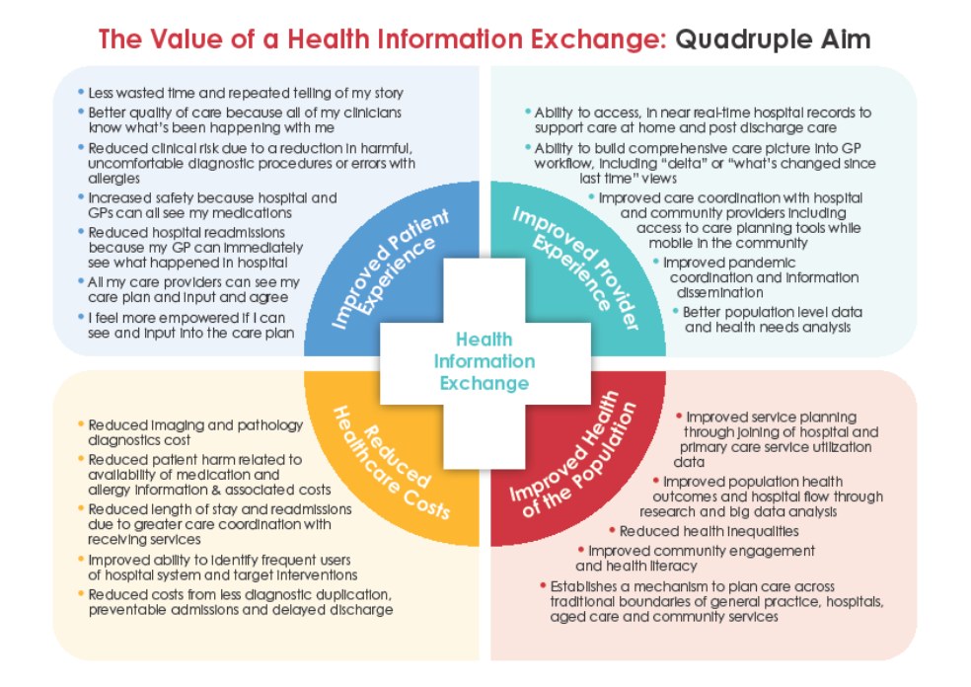

Evidence for the benefits of a health information exchange
Much of the evidence of value for health information exchange comes from countries such as the USA and Israel that have had health information exchanges in place for many years. Many comparable health systems are putting in place such systems to bridge the gaps between disparate parts of the health system and delivery better quality, integrated care. The most mature have had them in place for more than two decades.

The benefits of a health information exchange are far-reaching and increasingly described in the literature. They include:
- Improved safety and quality of care through real time medications information (Nahm et al 2020; Sakar 2022; Schoenbaum & Seckman 2019).
- Reduced costs for pathology, imaging, and other investigations due to reduced duplication of ordering (Mahajan, 2016).
- Improved consumer satisfaction derived from decrease in repeat history telling, improved coordination between acute and primary care providers and greater autonomy and mutuality of health care (HTSA, 2020; Healthcare Israel, 2020; Holmgren & Adler-Milstein, 2017).
- Improved service planning and other population-based health care interventions once data can be aggregated and made available for health researchers (Yeung 2019).
- Specific improvements such as reduced readmissions, greater delivery of chronic disease monitoring and early intervention for potentially preventable diseases (Nahm et al, 2020; Sakar 2020; Vest et al 2019).
- Key enabler for the delivery of virtual care models, particularly those that involved multiagency input where the health information exchange becomes the common platform for recording patient data (HTSA, 2020; Sakar 2022).

In a 2022 review article on the value that health information exchange brings to health services, Sakar (2022) highlighted seven main areas that more than 200 studies had indicated strong benefit for health information exchange. These were:
- Information Dissemination: this is a core function of health information exchange and has been shown to improve continuity of care, service transitions and patient experience.
- Delivery of Health Care: benefits here relate to availability of a more comprehensive picture of the patient (such as full medications or social history), the aggregations of health care information at a population level to support system planning and the broad benefit of putting in place a solution to lack of interoperability between the myriad of agencies delivering health care in any system or geographic location.
- Hospitals: key benefits specifically aligned to hospital care include a reduced admission rate, clinical benefit from the sharing of diagnostic data (pathology and imaging) and improved continuity of care between primary care, outpatient care and inpatient care. Overall efficiency savings (reduced costs) have also been described for hospitals operating within a health information exchange system as well as opening opportunities for advanced analytics to drive clinical decision-making.
- Hospital Emergency Services: These services are worth mentioned specifically due to the potential positive clinical impact a well-designed health information exchange can make to clinical care and patient safety. Health information exchange can be a major source for studying service utilization, causes for return visits, and the impact of social determinants of health on ED visits. In these settings access to accurate medication information can be critical to rapid and accurate assessment and a broader view on social history and background can improve care coordination and flow through departments.
- COVID19: Pandemic responses, such as those for COVID19, were greatly assisted by health information exchange to enable the matching of hospital, primary care, and public health data sets and to support accurate reporting and prediction. Where health information exchanges also had a patient portal function, this enabled rapid dissemination of health information and overall improved health outcomes. The lack of effective information sharing between residential aged care was particularly noted as problematic.
- Health Disparities: Health information exchange provides the opportunity for unbiased exchange of health data and knowledge to support population health. When combined with patient portals, this can have a significant impact on population health outcomes. Challenges were noted with rural and indigenous populations where access to digital technologies may be inequitable to begin with.
- Computer Security & Confidentiality: Key issues raised here include establishing a core principle of securely stored or exchanged information to protect privacy and maintain confidentiality. The critical role of local and national legislation is raised as it the use of new technologies such as blockchain and FHIR.

Towards a solution
The Connected Care project has worked with primary care clinicians, hospital clinicians and consumers to identify and document the user requirements of a HIE for South Australia. The technical and business requirements to achieve the user requirements have also been drafted in partnership with Digital Health SA.

There are continued advances in technology and the number of commercially available products to support a HIE. Solutions internationally vary between customed designed and off the shelf products.

United States
Much of the innovation and development for health information exchange has been driven out of the US since the passing of Health Information Technology for Economic and Clinical Health (HITECH) Act of 2009. For the first time, this legislation provided data standards and a requirement for providers receiving funding from the Federal Government to comply with data sharing and governance standards. This has seen a proliferation of ways of delivering health information exchange with models including state-based hosting, independent not-for-profit organisations or other hybrid models for the broker and host of the health information exchange.

Europe and the UK
A number of initiatives are in place across the NHS England but recent developments from NHS Scotland and Northern Ireland see attempts to join up health (acute and primary) and social care, underpinned by the deployment of the Rhapsody platform (by Lyniate) as part of the rollout of Epic EMR. This project (“Encompass”) seeks to enable flows of information between sectors to reduce duplication and support quality of care (HSCNI, 2020). TrakCare by Intersystems is used in NHS Scotland to provide a unified record between primary, acute and social care providers.

Israel & Middle East
Probably the best known instance of a system-wide, query-based deployment of a health information exchange is the deployment of dbMotion (Altera) across all of Israel’s public hospital, primary health care and military health services which has been in place for more than 20 years. This is a true, national HIE system and enables seamless care irrespective of where a citizen is accessing care (Healthcare Israel, 2020).

References
Holmgren AJ, Adler-Milstein J. Health Information Exchange in US Hospitals: The Current Landscape and a Path to Improved Information Sharing. J Hosp Med 2017 Mar;12(3):193-8.

Healthcare Israel, 2022, The Implementation of a National Health Information Exchange Platform in Israel: Digital Case Study, Inter-American Development Bank, available from https://socialdigital.iadb.org/en/sph/resources/research-publications/19173 accessed 23/12/2022

Health Translation SA, 2020, Continuity of Care Across the Primary and Acute Care Interface Situational Analysis; available from https://healthtranslationsa.org.au/wp-content/uploads/2020/12/HTSA-Situational-Analysis-Continuity-of-Care-Across-the-Primary-and-Acute-Care-Interface.pdf accessed 23/01/23

Lenert, Leslie ; McSwain, Brooke Yeager, 2020, Balancing health privacy, health information exchange, and research in the context of the COVID-19 pandemic Journal of the American Medical Informatics Association : JAMIA, 2020, Vol.27 (6), p.963-966 DOI: 10.1093/jamia/ocaa039; PMID: 32232432

Mahajan, Anish P Health Information Exchange—Obvious Choice or Pipe Dream? JAMA internal medicine, 2016, Vol.176 (4), p.429-430 DOI: 10.1001/jamainternmed.2016.0149; PMID: 26974128

Nahm, E; Schoenbaum, A; Behm, C; Rowen, L; Health Information Exchange: Practical Overview and Implications for Nursing Practice The Journal of nursing administration, 2020, Vol.50 (11), p.584-589 DOI: 10.1097/NNA.0000000000000941; PMID: 33105335

Sarkar, IN (2022) Transforming Health Data to Actionable Information: Recent Progress and Future Opportunities in Health Information Exchange, IMIA Yearbook of Medical Informatics 2022 31(1):203-214, DOI: 10.1055/s-0042-1742519

Schoenbaum AE, Seckman C. Impact of a Prescription Drug Monitoring Program on Health Information Exchange Utilization, Prescribing Behaviors, and Care Coordination in an Emergency Department. Comput Inform Nurs 2019 Dec;37(12):647-54.

Vest, Joshua R. ; Kash, Bita A. Differing Strategies to Meet Information-Sharing Needs: Publicly Supported Community Health Information Exchanges Versus Health Systems' Enterprise Health Information Exchanges The Milbank quarterly, 2016, Vol.94 (1), p.77-108 DOI: 10.1111/1468-0009.12180; PMID: 26994710

Vest, Joshua R. ; Unruh, Mark Aaron ; Freedman, Seth ; Simon, Kosali Health systems' use of enterprise health information exchange vs single electronic health record vendor environments and unplanned readmissions Journal of the American Medical Informatics Association : JAMIA, 2019, Vol.26 (10), p.989-998 DOI: 10.1093/jamia/ocz116; PMID: 31348514

Yeung T. Local health department adoption of electronic health records and health information exchanges and its impact on population health. Int J Med Inform 2019 Aug;128:1-6.

